Parker County was directed by the Texas Commission on Environmental Quality (TCEQ) to establish a Stormwater Management Program to minimize or eliminate pollution to creeks and streams. A small area of land in the northeast portion of the county which drains into Ash Creek was designated as an “urbanized area” by the 2000 Census and will receive the focus of this program. This area is bounded by Highland Road and Highway 199 and runs south and east through Sanctuary to Ash Creek. See attached Urbanized Census Map of Parker County
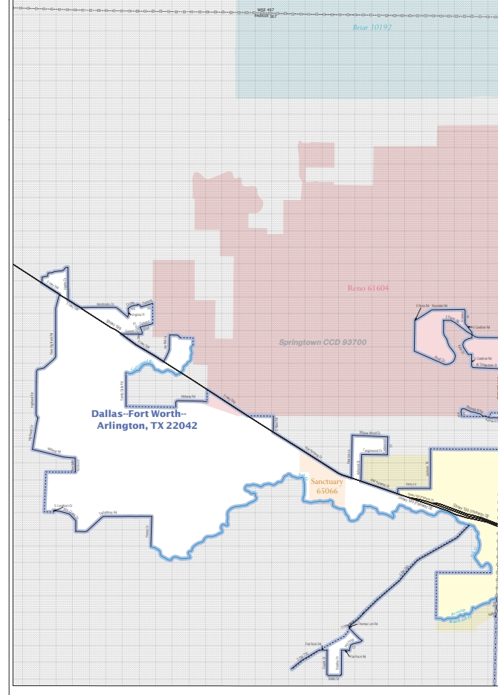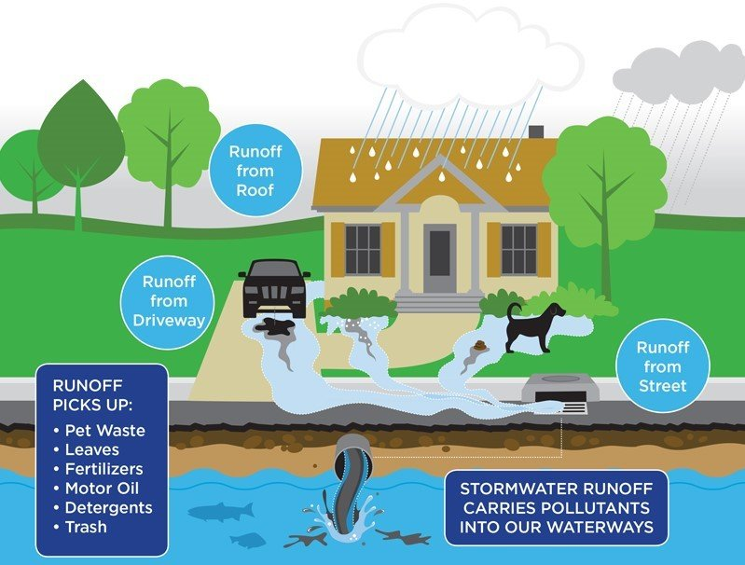
Polluted stormwater runoff can have many adverse effects on plants, animals, fish, and people. Sediments from construction sites can harm aquatic plants which help clean the water. Excess nutrients from fertilizers, animal waste, and sewage can cause algae blooms which start a process that could result in oxygen depletion in our streams; killing fish and other aquatic organisms. Pathogens from sewage can result in health risks to anyone who swims or wades in the water. Any questions regarding Stormwater Management contact Parker County Permitting Department 817-598-6175

